**CSC 573 Go-Back-*N* ARQ**

Name 1: Parth Kanakiya Student ID 1: 200369201

Name 2: Anil Kumar Yalla Student ID 2: 200365810

**Task-1: Effect of Window Size N**

For task-1, MSS=500 bytes and loss probability=0.05 and window size is varied over a range of {1,2,4,8,16,32,64,128,256,512,1024}.

When the same file is transmitted 5 times, the time taken for each data transfer is as shown below.

| **N** | **Time #1** | **Time #2** | **Time #3** | **Time #4** | **Time #5** | **Average Time** |
| --- | --- | --- | --- | --- | --- | --- |
| 1 | 263.5119102 | 268.2885908 | 301.8509211 | 292.5739232 | 286.4967525 | 282.5444196 |
| 2 | 242.102304 | 245.550764 | 234.7873133 | 242.4903416 | 246.6664305 | 242.3194307 |
| 4 | 210.429162 | 211.9069882 | 218.5397109 | 215.6027016 | 232.3855905 | 217.7728306 |
| 8 | 184.935741 | 185.0381713 | 197.2216862 | 186.969224 | 176.396031 | 186.1121707 |
| 16 | 163.543434 | 169.3478723 | 182.0552416 | 181.7886304 | 182.403501 | 175.8277359 |
| 32 | 155.497215 | 140.5898809 | 130.272408 | 148.622552 | 147.3690435 | 144.4702199 |
| 64 | 98.3862318 | 99.5381288 | 104.4934177 | 97.131892 | 96.3651885 | 99.18297176 |
| 128 | 100.632965 | 96.9715542 | 120.5482411 | 108.4225584 | 104.227557 | 106.1605752 |
| 256 | 120.003612 | 95.0260181 | 123.3996502 | 113.8458672 | 110.574891 | 112.5700077 |
| 512 | 119.76 | 117.33606 | 113.564326 | 115.487563 | 117.567453 | 116.7430804 |
| 1024 | 117.654734 | 115.612344 | 115.25432 | 110.765342 | 111.89653 | 114.236654 |

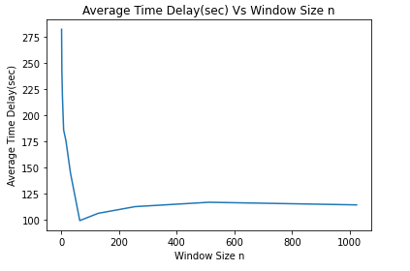

**Effect of window size N over the delay and the shape of the curve.**

Here the average delay and shape of the curve depends on the random value chosen by the random function in the range of [0,1]. But the chosen P=0.05 is comparatively very small considering the range so , if we ignore this random function effect,

We can observe that the average delay is very large when N is too small or too large.

When N=1, it will act as a stop and wait protocol, where for transmission of the next packet, it waits for acknowledgement of the previous packet to be received and the average delay is large.

When N is too large,it will send more packets parallelly, it is efficient if the network is reliable, but in this case, when there is scope for errors, the server discards some packets and if they are successive packets, delay increases because client(sender) has to wait till retransmit time to expire and all the frames from that sequence number has to be retransmitted.

So in this case window size shouldn't be too small or too large. It should be 64.

**Task-2 Effect of MSS**

For this task window size N = 64 and the loss probability p = 0.05 and vary the MSS in the range of {100,200,300,400,500,600,700,800,900,1000}.

The time delay for each transfer is as shown below.

| **MSS** | **Time #1** | **Time #2** | **Time #3** | **Time #4** | **Time #5** | **Average Time** |
| --- | --- | --- | --- | --- | --- | --- |
| 100 | 564.528352 | 575.8189191 | 570.1736355 | 581.4642026 | 575.8753719 | 573.5720962 |
| 200 | 310.415404 | 298.2422513 | 304.3288279 | 307.3721161 | 302.576342 | 304.5869883 |
| 300 | 167.087183 | 173.9773763 | 177.4224728 | 172.254828 | 168.8097314 | 171.9103183 |
| 400 | 150.207102 | 141.4994436 | 148.0301872 | 148.47671 | 145.1276345 | 146.6682154 |
| 500 | 98.6740317 | 96.267348 | 91.4539806 | 103.0060624 | 92.4769822 | 96.37568097 |
| 600 | 105.431696 | 98.2664352 | 112.596957 | 92.124783 | 102.36087 | 102.1561483 |
| 700 | 96.1406313 | 87.48090532 | 88.36455083 | 91.906778 | 79.52809575 | 88.68419224 |
| 800 | 68.8387582 | 76.58992973 | 72.20016 | 75.0881664 | 69.3246452 | 72.40833191 |
| 900 | 66.542734 | 64.24454104 | 72.6783392 | 64.8934758 | 71.38282338 | 67.94838268 |
| 1000 | 64.5534061 | 63.287653 | 64.8568463 | 63.238744 | 62.582321 | 63.70379407 |

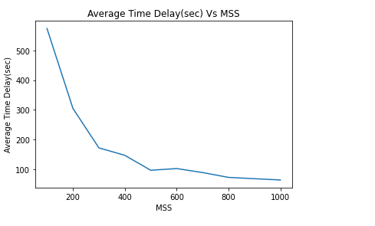

Here, we can observe that as the MSS value increases, the average time delay is decreasing. As MSS value increases, which implies that we send more data in a single transmission, so we require less number of transmissions to send data from sender to receiver. So which in turn results in lesser time to transmit the whole file. So we can conclude that the higher the MSS, the lesser the time delay.

**Task 3: Effect of Loss Probability p**

For this task, MSS = 500 bytes, window size N = 64 and vary the loss probability in range of {0.01,0.02,0.03,0.04,0.05,0.06,0.07,0.08,0.09,0.1}.

The time delay for each transfer is as shown below.

| **p** | **Time #1** | **Time #2** | **Time #3** | **Time #4** | **Time #5** | **Average Time** |
| --- | --- | --- | --- | --- | --- | --- |
| 0.01 | 33.7146199 | 32.75134509 | 31.90752 | 30.50370376 | 31.46697862 | 32.06883348 |
| 0.02 | 64.3348733 | 59.65597344 | 55.56193605 | 58.264521 | 55.475234 | 58.65850756 |
| 0.03 | 77.40037 | 92.880444 | 83.5923996 | 91.02283512 | 85.26424759 | 86.03205926 |
| 0.04 | 89.44285 | 101.4567824 | 89.43452 | 85.31593061 | 98.228612 | 92.77573899 |
| 0.05 | 119.353267 | 121.7166979 | 115.630863 | 119.0997889 | 117.120234 | 118.5841702 |
| 0.06 | 140.868642 | 133.3465297 | 139.5009471 | 140.2476342 | 128.5872024 | 136.510191 |
| 0.07 | 162.453283 | 167.8070864 | 156.2909138 | 181.7492244 | 156.1267345 | 164.8854484 |
| 0.08 | 185.477641 | 182.6954765 | 191.0419703 | 180.8407001 | 188.0743281 | 185.6260232 |
| 0.09 | 201.039242 | 212.3220569 | 205.142084 | 209.2449257 | 198.9878215 | 205.3472261 |
| 0.1 | 237.648652 | 252.0516002 | 249.5310842 | 226.8464402 | 237.05453 | 240.6264613 |

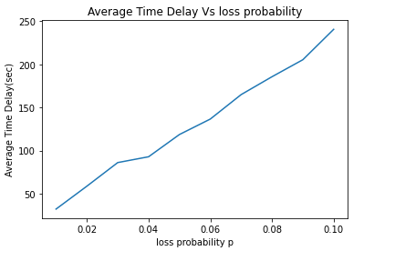

From the above graph, we can observe that as loss probability increases, the average time delay increases. This is because as the loss probability is increasing, there is more chance for packets to be discarded by the server. In this case, it requires more retransmits to send the data from the client to the server and the average time taken also increases.